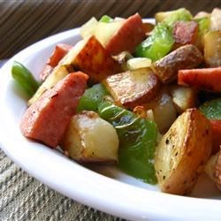
Kielbasa with Peppers and Potatoes
Prep Time: 10 Minutes, Cook Time: 30 Minutes
Ingredients:
1T | Our Family Fresh Vegetable Oil
1 | Red Bell Pepper, sliced
1 | Yellow Bell Pepper, sliced
16 oz | Package of Smoked Kielbasa, diced
6 | Medium Red Potatoes, diced
Directions:
Heat the oil in a saucepan over medium heat. Place kielbasa and potatoes in the saucepan. Cover, and cook 25 minutes, stirring occasionally, until potatoes are tender. Mix red bell pepper and yellow bell pepper into the saucepan, and continue cooking 5 minutes, until peppers are just tender.

