Ranch-Chive Popcorn
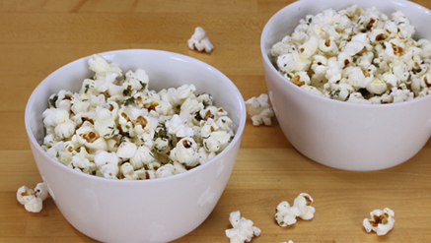
Prep Time: 10 Minutes, Cook Time: 3-4 Minutes

Ingredients:
4 Tbsp. Our Family Canola Oil or Safflower Oil
¾ cup Popcorn Kernels
1 ½ Tbsp. Dried Chives
1 Tbsp. Dried Parsley
1 tsp. Dried Dill
½ tsp. Our Family Garlic Powder
¼ tsp. Salt
¼ tsp.

Directions:
In a heavy-duty large pot, warm 1 tablespoon canola oil and a few popcorn kernels over high heat. Wait a couple minutes until these kernels have popped—this shows the oil is at the perfect popcorn-popping temperature. As quickly as possible, add in remaining popcorn kernels and cover with a lid. Reduce the heat to medium-high. Using potholders and shaking the pot constantly as the kernels pop, cook until the popping slows down, about 3 to 4 minutes. Remove the pot from heat but keep the lid on; some remaining kernels may continue to pop. In a small bowl, stir together oil and seasonings to combine. Carefully transfer the hot popcorn into a large bowl. Drizzle with the herbed oil, tossing as you add the oil so all the popcorn is coated. Serve.

