Grilled Heirloom Tomato and Goat Cheese Pizza
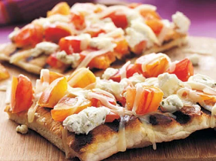
Prep Time: 11 Minutes, Cook Time: 4 Minutes
Amount | Ingredient
1 can | Our Family Refrigerated pizza crust
1 clove | Garlic clove (halves)
1 tomato | 1 large heirloom tomato
3/4 Cup | Crumbled goat cheese
½ cup | Our Family Mozzarella cheese
Directions
1. Prep grill to medium heat
2. Unroll dough onto baking sheet coated with cooking spray;
pat dough into 12x9 inch rectangle
3. Place dough on grill rack coated with cooking spray;
grill 1 minute or until light brown. Turn over dough.
Rub with garlic, and sprinkle with tomato and cheese.
Close grill, and let grill for 3 minutes.
Serve immediately
Grilled Heirloom Tomato and Goat Cheese Pizza
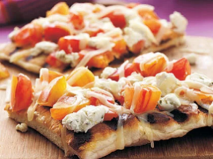
Prep Time: 11 Minutes, Cook Time: 4 Minutes
Amount | Ingredient
1 can | Our Family Refrigerated pizza crust
1 clove | Garlic clove (halves)
1 tomato | 1 large heirloom tomato
3/4 Cup | Crumbled goat cheese
½ cup | Our Family Mozzarella cheese
Directions
1. Prep grill to medium heat
2. Unroll dough onto baking sheet coated with cooking spray;
pat dough into 12x9 inch rectangle
3. Place dough on grill rack coated with cooking spray;
grill 1 minute or until light brown. Turn over dough.
Rub with garlic, and sprinkle with tomato and cheese.
Close grill, and let grill for 3 minutes.
Serve immediately
Grilled Heirloom Tomato and Goat Cheese Pizza
Prep Time: 11 Minutes, Cook Time: 4 Minutes
Amount | Ingredient
1 can | Our Family Refrigerated pizza crust
1 clove | Garlic clove (halves)
1 tomato | 1 large heirloom tomato
3/4 Cup | Crumbled goat cheese
½ cup | Our Family Mozzarella cheese
Directions
1. Prep grill to medium heat
2. Unroll dough onto baking sheet coated with cooking spray;
pat dough into 12x9 inch rectangle
3. Place dough on grill rack coated with cooking spray;
grill 1 minute or until light brown. Turn over dough.
Rub with garlic, and sprinkle with tomato and cheese.
Close grill, and let grill for 3 minutes.
Serve immediately
Grilled Heirloom Tomato and Goat Cheese Pizza
Prep Time: 11 Minutes, Cook Time: 4 Minutes
Amount | Ingredient
1 can | Our Family Refrigerated pizza crust
1 clove | Garlic clove (halves)
1 tomato | 1 large heirloom tomato
3/4 Cup | Crumbled goat cheese
½ cup | Our Family Mozzarella cheese
Directions
1. Prep grill to medium heat
2. Unroll dough onto baking sheet coated with cooking spray;
pat dough into 12x9 inch rectangle
3. Place dough on grill rack coated with cooking spray;
grill 1 minute or until light brown. Turn over dough.
Rub with garlic, and sprinkle with tomato and cheese.
Close grill, and let grill for 3 minutes.
Serve immediately

