Easy Tuna Casserole
Prep Time: 15 Minutes, Cook Time: 30 Minutes
Amount | Ingredient
3 cups | Our Family Macaroni - cooked
1 can | Tuna, drained
1 can | Our Family Condensed Cream of Chicken Soup
1 Cup | Our Family Shredded Cheese
1 ½ cups | French Fried Onions- Optional

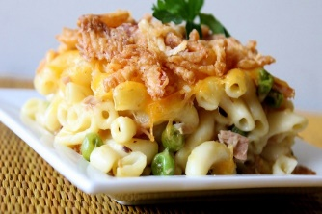

Directions
1. Preheat oven to 350 degrees F (175 degrees C).
2. In a 9x13-inch baking dish, combine the macaroni, tuna, and soup. Mix well, and then top with cheese.
3. Bake at 350 degrees F (175 degrees C) for about 25 minutes, or until bubbly. Sprinkle with fried onions, and bake for another 5 minutes. Serve hot.

Easy Tuna Casserole
Prep Time: 15 Minutes, Cook Time: 30 Minutes
Amount | Ingredient
3 cups | Our Family Macaroni - cooked
1 can | Tuna, drained
1 can | Our Family Condensed Cream of Chicken Soup
1 Cup | Our Family Shredded Cheese
1 ½ cups | French Fried Onions- Optional

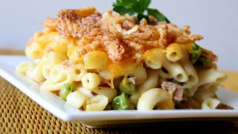

Directions
1. Preheat oven to 350 degrees F (175 degrees C).
2. In a 9x13-inch baking dish, combine the macaroni, tuna, and soup. Mix well, and then top with cheese.
3. Bake at 350 degrees F (175 degrees C) for about 25 minutes, or until bubbly. Sprinkle with fried onions, and bake for another 5 minutes. Serve hot.

Easy Tuna Casserole
Prep Time: 15 Minutes, Cook Time: 30 Minutes
Amount | Ingredient
3 cups | Our Family Macaroni - cooked
1 can | Tuna, drained
1 can | Our Family Condensed Cream of Chicken Soup
1 Cup | Our Family Shredded Cheese
1 ½ cups | French Fried Onions- Optional

Directions
1. Preheat oven to 350 degrees F (175 degrees C).
2. In a 9x13-inch baking dish, combine the macaroni, tuna, and soup. Mix well, and then top with cheese.
3. Bake at 350 degrees F (175 degrees C) for about 25 minutes, or until bubbly. Sprinkle with fried onions, and bake for another 5 minutes. Serve hot.

Easy Tuna Casserole
Prep Time: 15 Minutes, Cook Time: 30 Minutes
Amount | Ingredient
3 cups | Our Family Macaroni - cooked
1 can | Tuna, drained
1 can | Our Family Condensed Cream of Chicken Soup
1 Cup | Our Family Shredded Cheese
1 ½ cups | French Fried Onions- Optional

Directions
1. Preheat oven to 350 degrees F (175 degrees C).
2. In a 9x13-inch baking dish, combine the macaroni, tuna, and soup. Mix well, and then top with cheese.
3. Bake at 350 degrees F (175 degrees C) for about 25 minutes, or until bubbly. Sprinkle with fried onions, and bake for another 5 minutes. Serve hot.

