Quinoa Salad
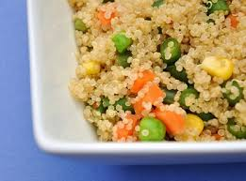
Prep Time: 10 Minutes, Cook Time: 20 Minutes

Ingredients:
1 C |  | Our Family Quinoa
1 1/2 C |  | water
1/2 Tsp |  | salt
2 C |  | Our Family Frozen mixed Veggies
2 Tbs  1 Tbs |  | Our Family Lemon Juice  Our Family Olive Oil

Directions:

PPlace Quinoa into pot, add water and salt. Bring to a boil, cover and turn heat down to simmer. Cook for 20 minutes. Remove from heat, fluff with fork and serve.

Mix quinoa, vegetables, lemon juice and olive oil thoroughly but gently. Taste and season if necessary.

*Rice may be substituted for Quinoa

