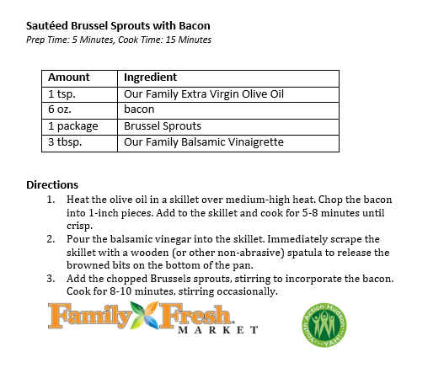
Sautéed Brussel Sprouts with Bacon
Prep Time: 5 Minutes, Cook Time: 15 Minutes
Amount | Ingredient
1 tsp. | Our Family Extra Virgin Olive Oil
6 oz. | bacon
1 package | Brussel Sprouts
3 tbsp. | Our Family Balsamic Vinaigrette

Directions
- Heat the olive oil in a skillet over medium-high heat. Chop the bacon into 1-inch pieces. Add to the skillet and cook for 5-8 minutes until crisp.
- Pour the balsamic vinegar into the skillet. Immediately scrape the skillet with a wooden (or other non-abrasive) spatula to release the browned bits on the bottom of the pan.
- Add the chopped Brussels sprouts, stirring to incorporate the bacon. Cook for 8-10 minutes, stirring occasionally.

